ASSIGNMENT # 1

QUESTION 1

CODE:
a=[]
Sum=0
counter=0

n=int(input("enter number of times you run around a racetrack:"))
for i in range(n):
time_of_lap=int(input("enter the lap time for each round:"))
a.append(time_of_lap)
Sum+=time_of_lap
counter+=1
slowest=max(a)
print("slowest lap time",slowest)
fastest=min(a)
print("fastest lap time",fastest)
print("average lap time:",Sum/counter)

OUTPUT:
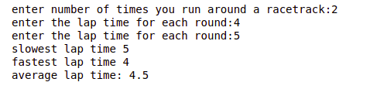
QUESTION 2:
CODE:
month = 0
totalInches = 0
years = int(input("enter the number of years: "))
for i in range (years):
for j in range(12):
rainfall = int(input(f"enter the inches of rainfall for the month and for the year: "))
month+=1
totalInches +=rainfall
averageRainFall = totalInches/month
print("total number of months: ",month,"months")
print("the total inches of rainfall: ",totalInches ,"inches")
print("the average rainfall per month for the entire period: ",averageRainFall,"inches")

OUTPUT:
